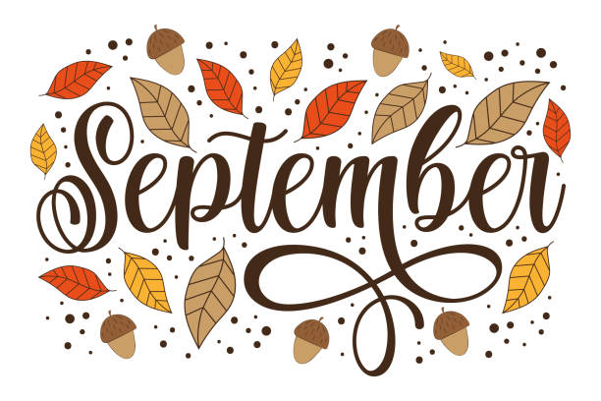

Hello September! As summer winds down and fall begins, we thank you for making Hacienda Del Pismo such a wonderful place to call home. Below you'll find this month's updates and reminders.

What’s New at the Park?
Manager Update
As many of you know, we said goodbye to Joel last month. After 9 months with us, he's off to explore a new career path. We thank him for his time here and wish him all the best!
And a big, friendly welcome to our new Park Manager, George! With nearly 15 years of community management experience, he's already settling in and is excited to meet more of you. If you haven't already, stop by the office and say hello!

Office Update
Our wonderful Office Assistant, Kaili, will be going on maternity leave starting around the end of September. We’re so excited for her and her growing family!
Come help us celebrate her at our upcoming Ice Cream Social gathering as we send her off.

Community Reminders
Dumpsters: No yard clippings, construction, or remodeling debris in community dumpsters. Please have your landscapers/contractors haul away their own materials.
Pet Waste: Please pick up after your dogs and dispose of waste properly.
Pool: Open 8 AM - 7 PM. The gate will now be electronically locked between the hours of 7 PM until 8AM.
New! Pool dumbbells are now available for everyone to use — thanks to a generous resident!

Bingo Day Recap
Our first Bingo Day on August 7th was a hit! About 15 residents joined us for games, prizes, and laughs in the clubhouse. Thanks to everyone who came and to our volunteer who made it happen!
With this great turnout, we're making Bingo a monthly event — as long as interest and volunteers continue. Next time: longer games and more chances to win!

National Days:
September 7th, 2026 – Labor Day
September 11th, 2026 – Patriot Day / National Day of Service and Remembrance
September 22nd, 2026 – National Ice Cream Cone Day and the official beginning of fall!

Park Events:
Next Bingo Day – September 11th
12:00 PM to 1:00 PM | Clubhouse
Join us for another fun afternoon of Bingo in the clubhouse!
We're extending the fun this time with longer play and even more prizes to give away.
Free to play and all are welcome. Donations are appreciated and will go directly toward future events.

Fresh & Free Farmer’s Market — Tuesday, September 15th
11:30 AM – 12:30 PM | Outside the Clubhouse
Our monthly Farmers Market returns! All produce is free for residents. This market happens every 3rd Tuesday of the month, so mark your calendar and stop by.

Ice Cream Social & Farewell — Friday, Sept. 18th
Tuesday, Sept. 18 | 1:00 - 2:00 PM | Clubhouse
Double scoop of celebration! In celebration of National Ice Cream Cone Day and as a goodbye and good luck to our wonderful office assistant Kaili as she goes on maternity leave, come enjoy an ice cream social at the clubhouse!

Community Events:
Art in the Park Shell Beach
Sunday, Sept 6th at 10:00 AM at Dinosaur Caves Park
Enjoy this monthly pop-up market at Dinosaur Caves Park including local artisans, music, food and family fun!

Movies in the Park
Friday, Sept 11th 7:00 PM – 9:00PM at Dinosaur Caves Park
Grab your blankets, pack your favorite snacks, and join the Rec Dept for a magical movie night under the stars! This free, family-friendly outdoor screening is the ultimate laid-back evening - just bring a lawn chair and get cozy.

Pismo Beach Corgi Fest
Saturday, Sept 12th 10:00 AM – 1:00PM at Pismo Bach Pier
Get ready for maximum fluff and stubby-legged excitement! Part of the epic “Corgi Nation Vacation,” this wildly popular, pet-friendly festival takes over the beach with a bustling vendor village, hilarious contests, and high-speed corgi races.

Quote Of The Month:
"Of all the seasons, autumn offers the most to man and requires the least of him.” – Hal Borland

